Module 1: Software Engineering, HTML and CSS

1. (a) Create a html web page that contains a button with which it is possible to change the text that is shown on the screen. The file ButtonDemo.html has a JavaScript function named change_text() which is called after the button is pressed. When the button is pressed repeatedly the text changes Hello! ... Well done! ... Hello! ... Well done! ... Hello! ..

1.=====Code

<html>

<script>

function change_text()

{

var text=document.createTextNode("Hello!...well done!...");

var p=document.createElement(p);

var temp=p.appendChild(text);

document.body.appendChild(temp);

}

</script>

<body>

<input type="submit" value="button" onclick="change_text()">

</body>

</html>

1.Output ScreenShot

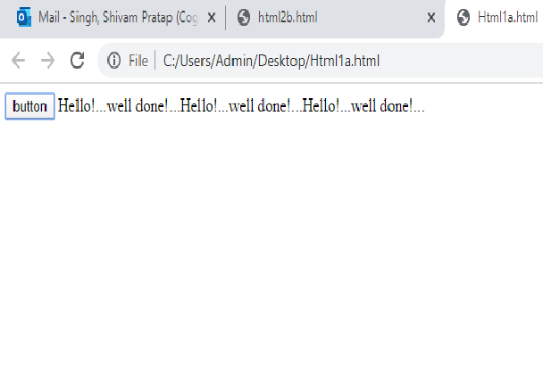

(b) Modify the program so that the initial text shown on the screen is "Monday", and it will change in the following way when the button is

pressed repeatedly: Monday ... Tuesday ... Wednesday ... Thursday ... Friday ... Saturday ... Sunday ... Monday ... Tuesday ... etc. You should also change the button text so that there is written "Change day" on the button.

(b)….. CODE////

<!DOCTYPE html>

<html>

<script>

var index=0;

function change_day()

{

if (index>6)

{

index=0;

}

var days=['Monday ... ','Tuesday ... ','Wednesday ... ','Thursday ... ','Friday ... ','Saturday ... ','Sunday ... '];

var text=document.createTextNode(days[index]);

var p=document.createElement(p);

var temp=p.appendChild(text);

document.body.appendChild(temp);

index=index +1;

}

</script>

<body>

<input type="submit" value="button" onclick="change_day()">

</body>

</html>

(b) output//////// screenshot

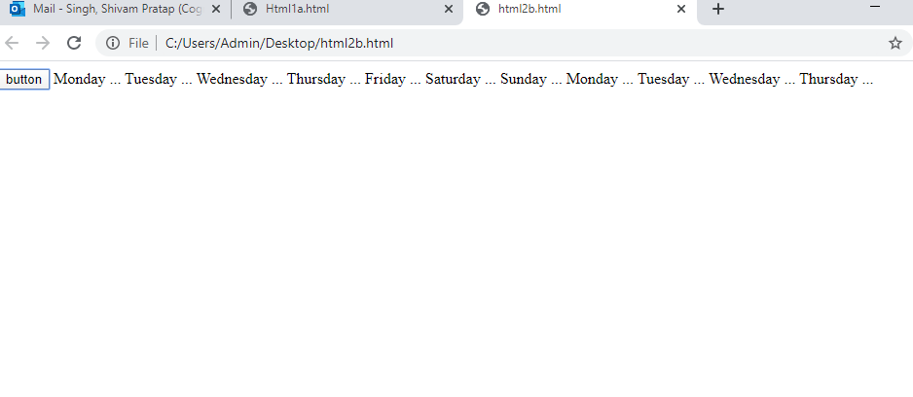

3. Using CSS properties create a calendar with following Calender Template:

3.CODE/////

<!DOCTYPE html>

<html>

<head>

<style>

* {box-sizing: border-box;}

ul {list-style-type: none;}

body {font-family: Verdana, sans-serif;

background-image: url("cssimg.jpg");

}

.month {

padding: 10px 25px;

width: 100%;

background: red;

text-align: center;

}

.month ul {

margin: 1

padding: 0;

}

.month ul li {

color: white;

font-size: 30px;

text-transform: uppercase;

letter-spacing: 3px;

}

.month .prev {

float: left;

padding-top: 10px;

}

.month .next {

float: right;

padding-top: 5px;

}

.weekdays {

margin: 0;

padding: 10px 0;

background-color: white;

}

.weekdays li {

display: inline-block;

width: 13.6%;

color: #666;

text-align: center;

}

.days {

padding: 10px 0;

background: #eee;

margin: 0;

}

.days li {

list-style-type: none;

display: inline-block;

width: 13.6%;

text-align: center;

margin-bottom: 5px;

font-size:12px;

color: blue;

}

.days li .active {

padding: 5px;

background: #1abc9c;

color: white !important

}

</style>

</head>

<body >

<h1 align="center">CSS Calendar</h1>

<div class="month">

<ul>

<li>

January<br>

<span style="font-size:18px">2020</span>

</li>

</ul>

</div>

<ul class="weekdays">

<li>Mo</li>

<li>Tu</li>

<li>We</li>

<li>Th</li>

<li>Fr</li>

<li>Sa</li>

<li>Su</li>

</ul>

<ul class="days">

<li>1</li>

<li>2</li>

<li>3</li>

<li>4</li>

<li>5</li>

<li>6</li>

<li>7</li>

<li>8</li>

<li>9</li>

<li>10</li>

<li>11</li>

<li>12</li>

<li>13</li>

<li>14</li>

<li>15</li>

<li>16</li>

<li>17</li>

<li>18</li>

<li>19</li>

<li>20</li>

<li>21</li>

<li>22</li>

<li>23</li>

<li>24</li>

<li>25</li>

<li>26</li>

<li>27</li>

<li>28</li>

<li><span class="active">29</span></li>

<li>30</li>

<li>31</li>

</ul>

</body>

</html>

==============OUTPUT- SCREENSHOT======

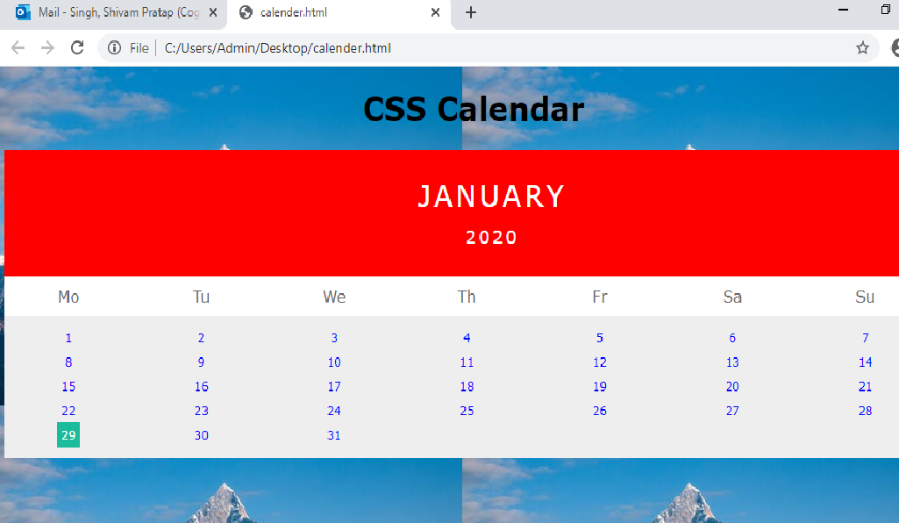

Module 2: Java Script and SQL

4. Write the queries Based on following Loan Schema:

Queries:

a. Write a query to display customer number, customer’s firstname , account number where the account status is terminated. Display the records sorted in ascending order based on customer number and then by account number.

Sqlquery==========

select cm.customer_number,cm.firstname,

am.account_number from

customer_master cm join account_master am on cm.customer_number=am.customer_number

where am.account_status="TERMINATED" order by cm.customer_number,am.account_number;

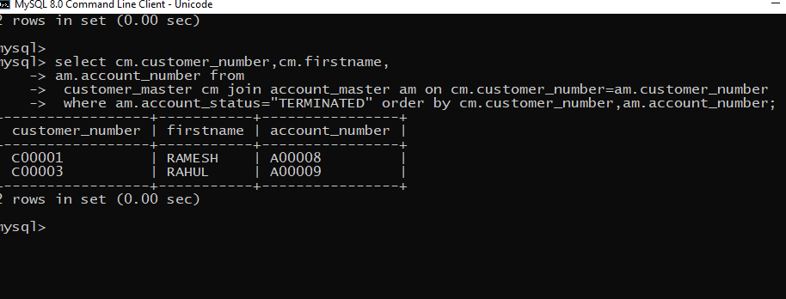

b. Write a query to display the number of accounts opened in each city. The query should display the Branch city and the number of No_of_Accounts for the branch city where we don’t have any accounts opened display 0. Display the records in the sorted order based on branch city

select count(am.account_number),bm.branch_city from

branch_master bm left join account_master am on bm.branch_id=am.branch_id

group by bm.branch_city

order by bm.branch_city;

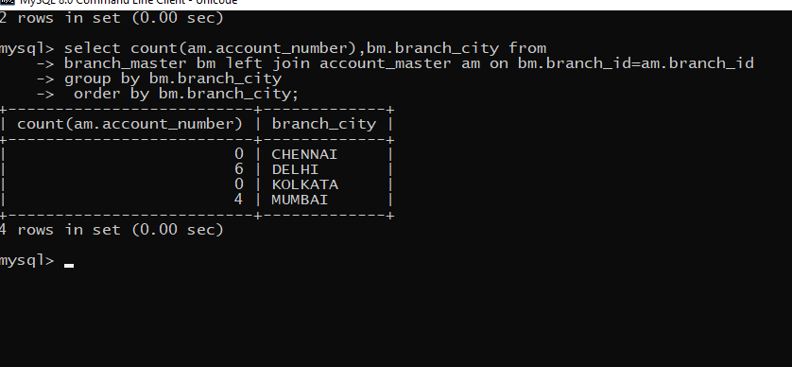

c. Write a query to display the customer number, customer firstname, customer lastname who has taken loan from more than 1 branch. Display the records sorted in order based on customer number.

select cm.customer_number,cm.firstname,cm.lastname

from customer_master cm join loan_details ld

on cm.customer_number=ld.customer_number

group by ld.customer_number

having count(ld.branch_id)>1

order by cm.customer_number;

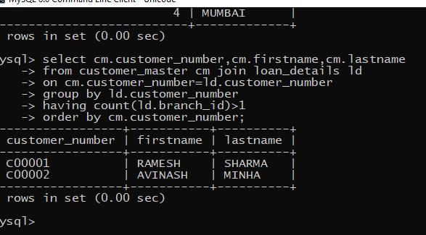

d. Write a query to display the number of clients who have asked for loan but they don’t have any account in the bank though they are registered customers. Give the count an alias name of Count

select count(ld.customer_number) Count from

loan_details ld join account_master am

on ld.customer_number=am.customer_number

where ld.customer_number

not in(select customer_number from account_master);

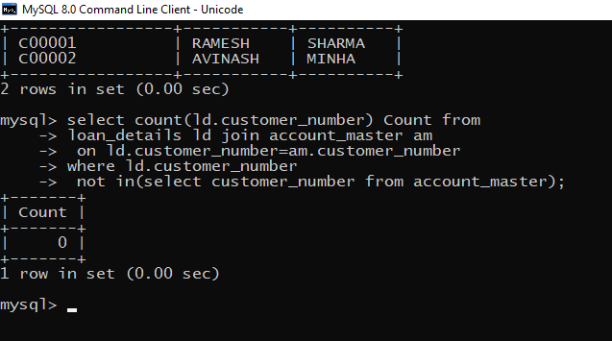

e. Write a equerry to display customers firstname, city and account number whose occupation are not business , Services or Student. Display the records sorted in ascending order based on customer firstname and by account number.

select cm.firstname,cm.customer_city,am.account_number

from account_master am join customer_master cm on am.customer_number=cm.customer_number

where cm.customer_number NOT IN

(select customer_number from customer_master where occupation ='SERVICE' or 'STUDENT' or 'BUSINESS' )

order by cm.firstname,am.account_number;

